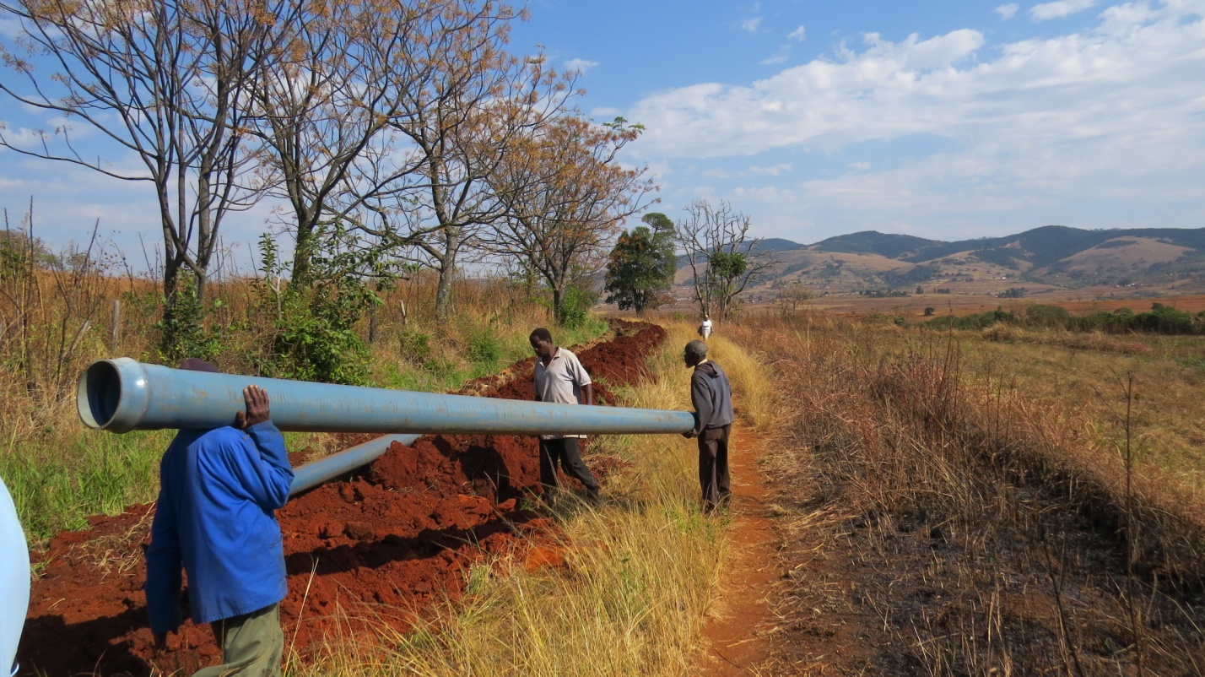
Mpatheni Community members laying the main lines from dam to irrigated fields (up to 1,609m of pipe has been laid)

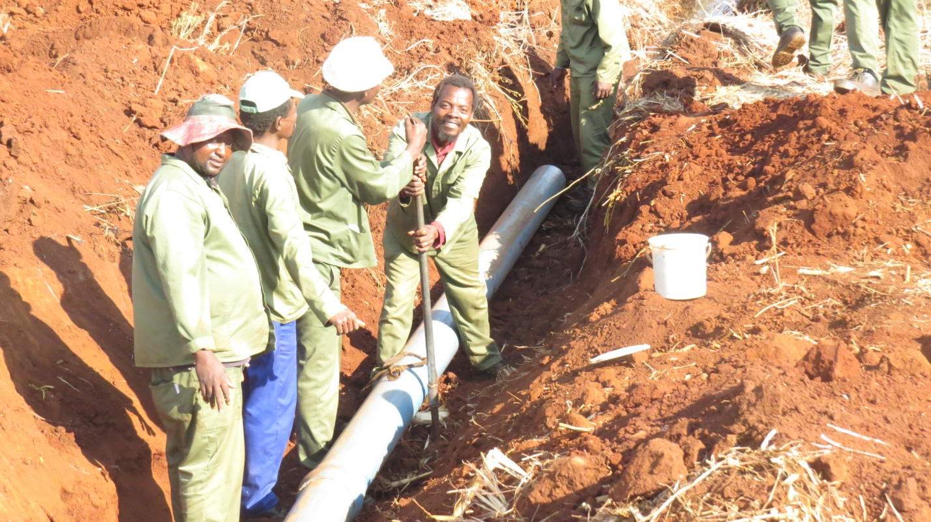
Staff from the Ministry of Agriculture assisting with the laying of the mainline at Mpatheni

